Fully Automatic Rewinding Machine with Core ZRF-600DY
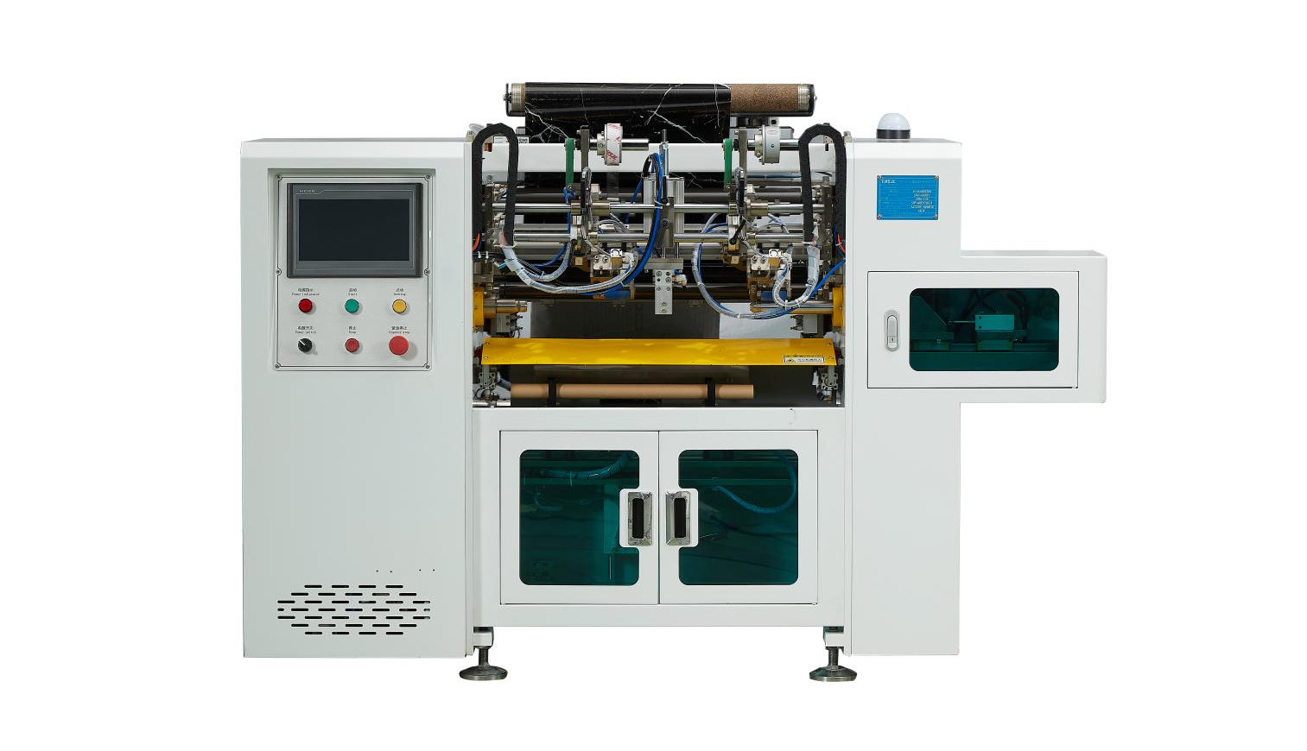
Equipment Layout：
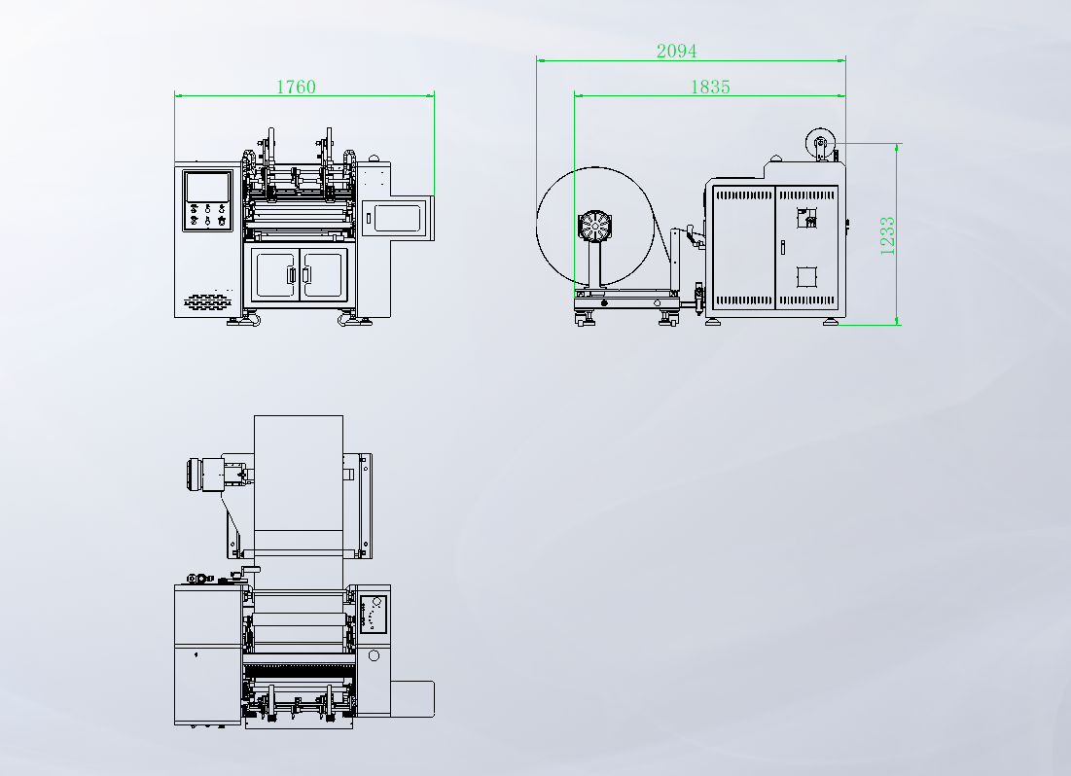
The specific parameters are as follows：
SWF-600DY | Fully automatic glueless rewinding machine with Core - suitable for various glueless materials such as: advertising paper, kraft paper, wallpaper, etc.
Abstract | Specification details | Quantity | Brand
The applicable range of this machine
Effective discharge width | 300-600mm
Maximum discharge diameter | 800mm
Unroll the paper core | 3inch
The inner diameter of the reel | 26mm（can change）
Maximum diameter of the roll | 80mm
Mechanical speed | 0-150m/min
Power supply | 380V 50HZ
Air source | 5KG(customer self-provided)
Discharge configuration
Discharge seat | Extended spooling of 3 inches | 1 set
Brake control system | Automatic control of cone taper for unwinding tension | 1 set
Correction system | CPC automatic deviation correction | 1 set | EURDOW
Examination paper configuration
Collect the scroll | 26mm air expansion shaft (replaceable) | 1 set
Reel motor | 1KW servo motor | 1 set | HCFA
Traction motor | 1.8KW servo motor | 1 set | HCFA
Traction reducer | Straight gear planetary reducer | 1 set | SMITECH
Rolling tension system | Motion controller linear control | 1 set | HCEA
Rolling shutter mechanism | 1KW servo winding machine | 1 set
Final labeling configuration
Sealing label | Servo control labeling length (adhesive tape) | 2 sets
Labeling motor | 750W servo motor | 1 set | HCFA
Labeling reducer | Straight gear planetary reducer | 1 set
Cutting knife mechanism | Tungsten steel round knife rotary cutting (with blade washing function) | 1 set
Cutting blade motor | 30W DC brushless motor | 1 set | MAIOLI
Electrical Control Department Configuration
Control system | Motion control system (One-click start, easy to change specifications) | 1 set | HCFA
Operation panel | Set production parameters and tension control parameters | 1 set | 10-inch MCGS HMI
Control box | Embedded control box with push-button panel | 1 set
Other configurations
Guide roller | Surface hard coating
Random data
Chinese and English instructions | Two copies each in electronic format and paper format | 2 sets
Operation Video |  | 1 set
Electrical wiring diagram | Two copies each in electronic format and paper format | 2 sets
Gas and Liquid Principle Diagram | Two copies each in electronic format and paper format | 2 sets
List of vulnerable parts and spare parts | Two copies each in electronic format and paper format | 2 sets
Common tools |  | 1 set

